How to Sign Up for a Swim Meet on Team Unify
Follow the steps below to sign up your child for an upcoming swim meet.
Any questions or trouble, please contact your coach.

- Go to team unify website (www.lebanonswimclub.org).

- Select Team Events and scroll down.
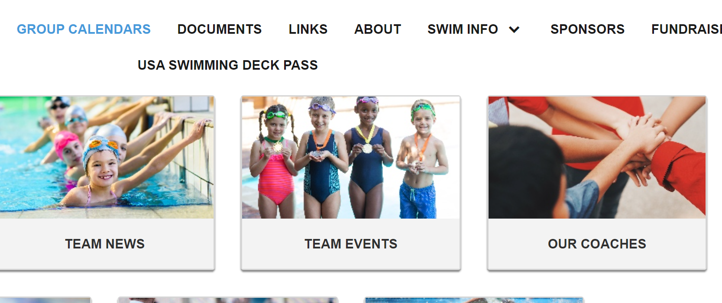

- Select “attend/decline” on the meet you plan to attend.
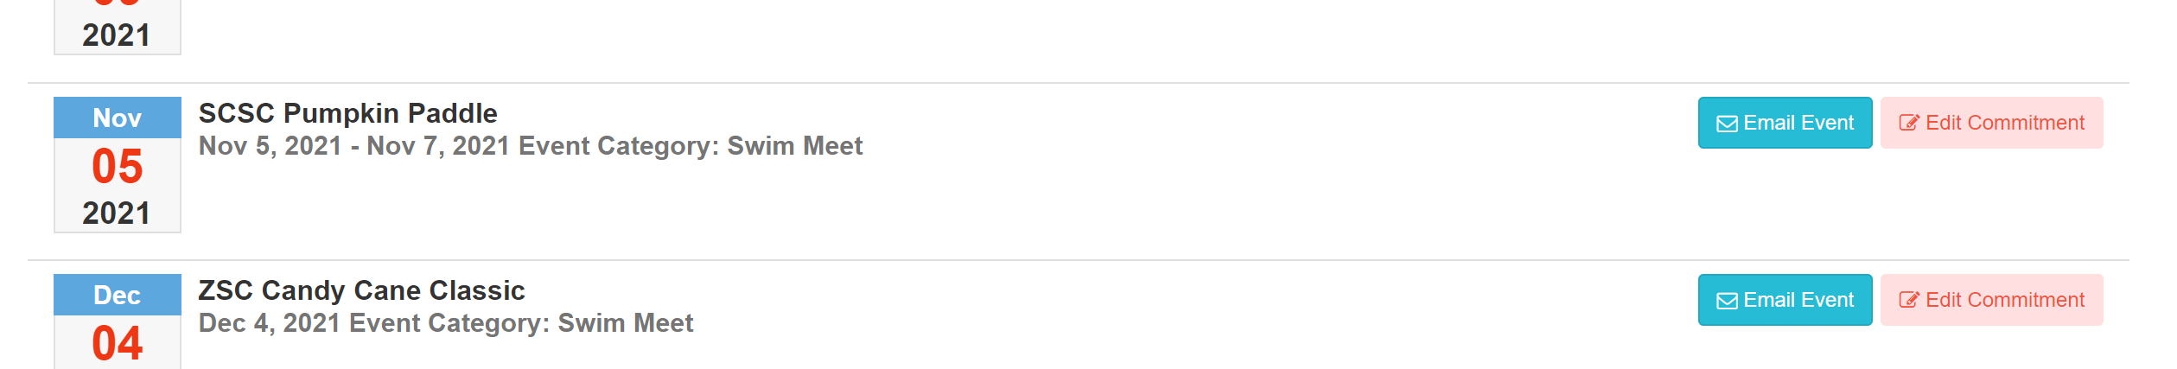

- Click on your child’s name.
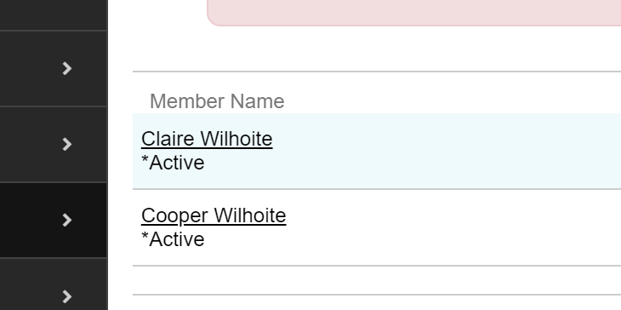

- Under “declaration” drop down box, select “Yes” or “No”. Include any comments needed for the coach in the “notes” box. This may include “cannot attend Sunday”, request certain events, etc.
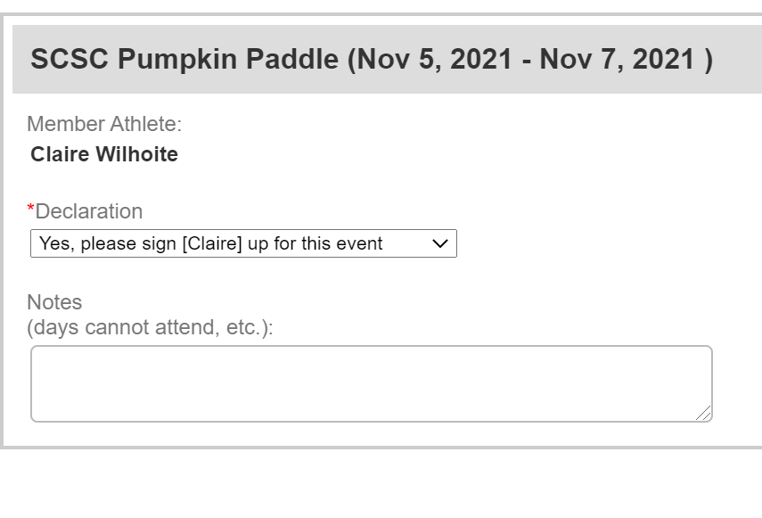
- Select “save changes” on the bottom right of the page.
